Sale-a-Bration Stamp Camp

Stamp camp is back! This stamp camp will be much different than in the past. Space will be limited so register right away. This event will have 4 projects. You will make a pizza box with note cards inside, an oversized card and envelope, a set of cards in an acetate box, and a 3D item that looks very artistic. This event will include more than $50.00 of product. You will receive a goodie bag when you arrive. Some of the products will be used in your projects. You will have a lot of product to take home, including a stamp set and door prizes. Get your friends together and register early to save your spot.

Sales and booking incentives will be offered as well. Have a date or two in mind so you can book a Sale-a-Bration party of your own.
Saturday, February 3rd
9am to 2pm
4404 Snowflake Dr. NW
$60.00
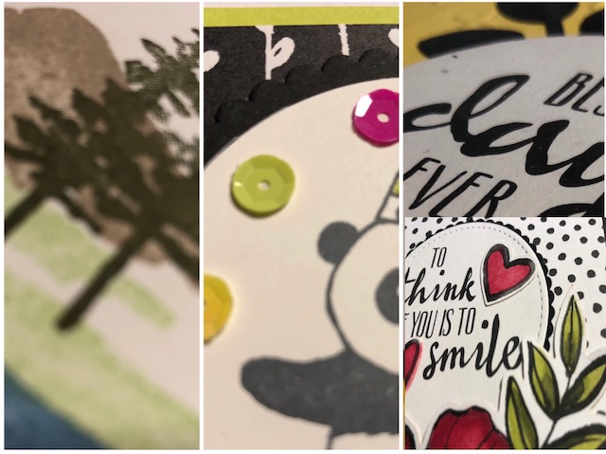
This includes:
4 mega projects, $50.00 worth of current and new product, the new Occasions catalog, lunch, door prizes, a stamp set, sales and booking incentives and much more.
To-go kit option is also available if you can’t attend the live event.
**********************************************************************************

Name: _______________________________________________________________________________________________

Address: _____________________________________________________________________________________________

Phone: ____________________________________ email: ___________________________________________________

Payment: $60. 00 (non-refundable) ______________________ Payment method:___________________

* I can’t attend Stamp Camp but I would like a to-go kit. Please mail my kit (including all of the free goodies and prizes) Shipping is included. This will be mailed by February 5th.

Payment can be made with cash, check or charge by mail, Paypal (Susan Legits) or over the phone. Please reserve your spot with $20. before spots run out. The remaining balance is due January 15th. (deposit and fee is non-refundable)

