Perfect Parcel
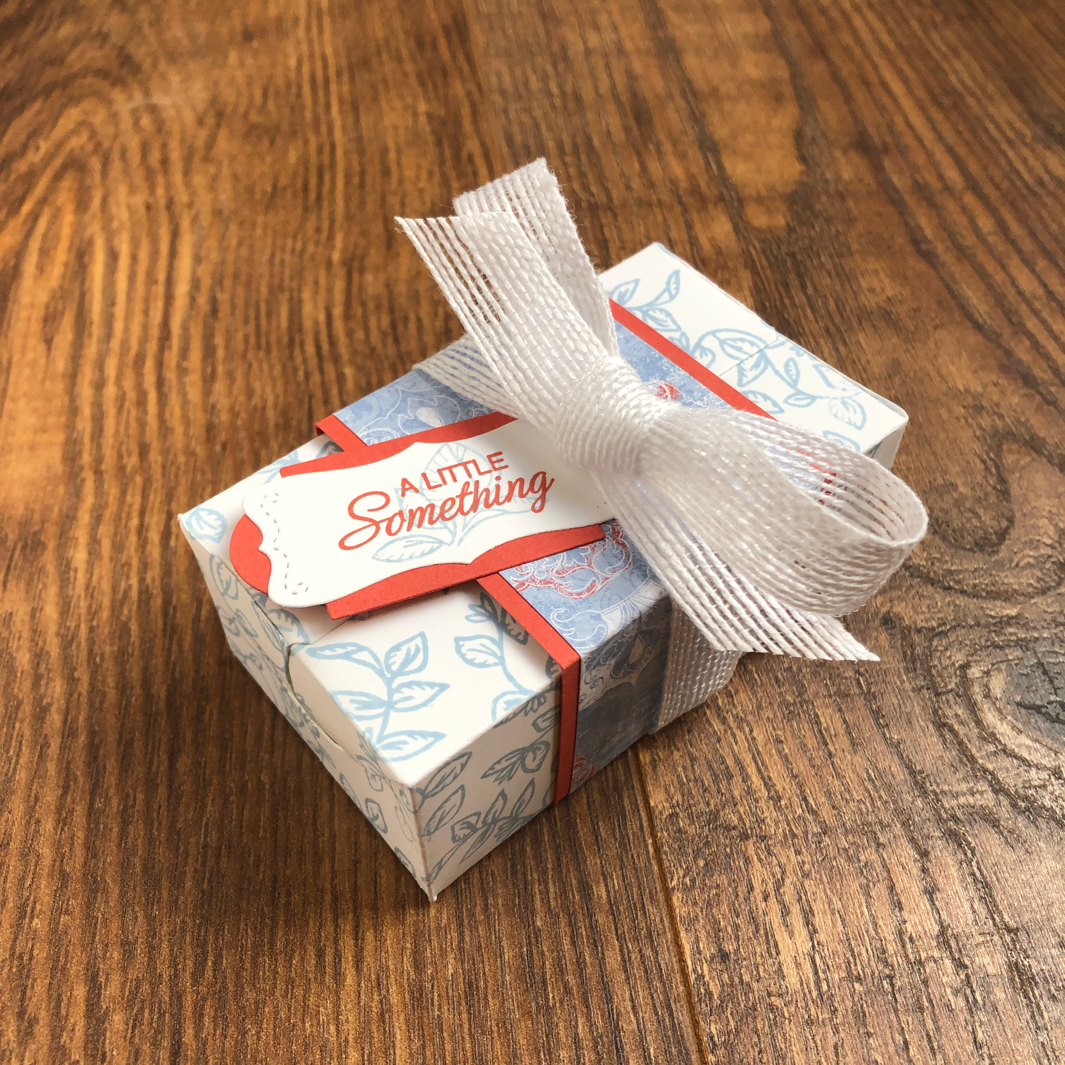
All images © 1990-2019 Stampin’ Up!®

Supplies:

Stamps: Parcels & Petals (cling 149317) Verdant Garden (photopolymer 149460)
Inks: Terracotta Tile (150086) & Seaside Spray (150085) Classic Stampin’ Pads
Paper: Whisper White (100730), Terracotta Tile (150884) & Woven Threads Designer Series Paper (149497)
Other: Perfect Parcel Dies (151107), Die cutting machine, 5/8” Flax Ribbon (148764), SNAIL (104332), Tear & Tape Adhesive (138995), Simply Scored Scoring Tool (122334)

Measurements:
- Whisper White: 4 1/4” x 6-1/2” (2 pieces) + scrap for stamping
- Terracotta Tile: 7-3/4” x 2” + scrap
- Woven Threads DSP: 7-3/4” x 1-3/4”

Instructions:
- Die cut the two pieces of Whisper White card stock with the large box die in the Perfect Parcels die set.
- Using Seaside Spray ink and the floral stamp from Verdant Garden, stamp the image repeatedly over the die cut pieces.
- Fold the box pieces on all of the score lines. All are folded in, except for the triangle on the long piece with the curve - this one is folded out.
- Add Tear & Tape Adhesive to the two end tabs on both of the die cuts. Glue the un-tabbed piece onto the tabbed piece, taking care to line up the centre score lines as this is the edge of the top of the box. Glue the other flat edge to the tabs. You will now have a box shape.
- On the long pieces with the curve… add a bit of Tear & Tape to the unstamped side of the folded triangles. Fold the two end pieces into the box first. Fold the other two pieces down, and flatten the box. When you do this, the taped triangles will glue themselves into position. Open the box again, and the tabs should move into place. This is the bottom of the box.
- Turn the box over. Fold the long straight edges down. You should have two triangles at the ends that can fold over the sides, and fit inside the slot.
- Stamp the sentiment from Verdant Garden onto a piece of scrap Whisper White cardstock in Terracotta Tile. Die cut with the appropriate die (see photo above).
- Die cut the backing piece of the tag using the other tag die from the Perfect Parcels dies, and Terracotta Tile cardstock. Adhere this to the back of the sentiment and set aside.
- Score the Terracotta Tile card stock at 1”, 2-1/2”, 4-5/8” & 6-1/8”. Run your bone folder across the folds. Glue the Woven Threads DSP on top and refold on the score lines. Wrap this around the box and glue together at the bottom.
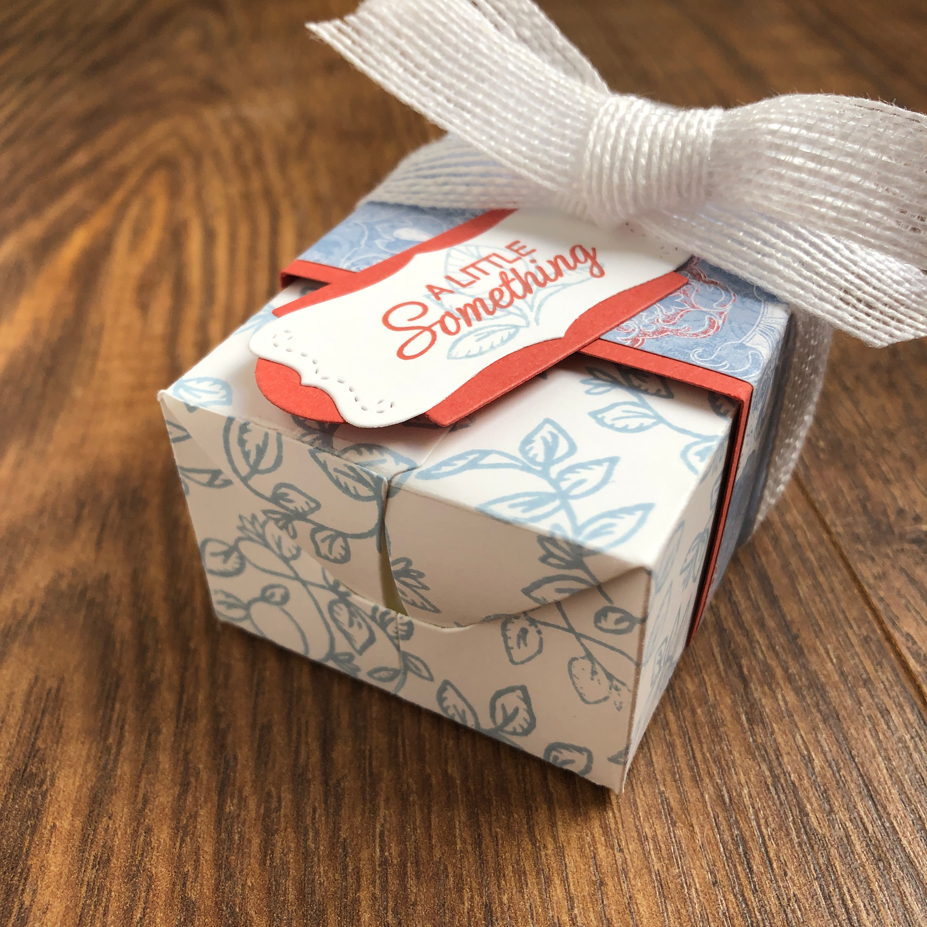
- Wrap the Flax Ribbon around the box, and tie in a box on the top. Add SNAIL to the back of the right half of the sentiment, and glue to the band.

