Parisian Beauty

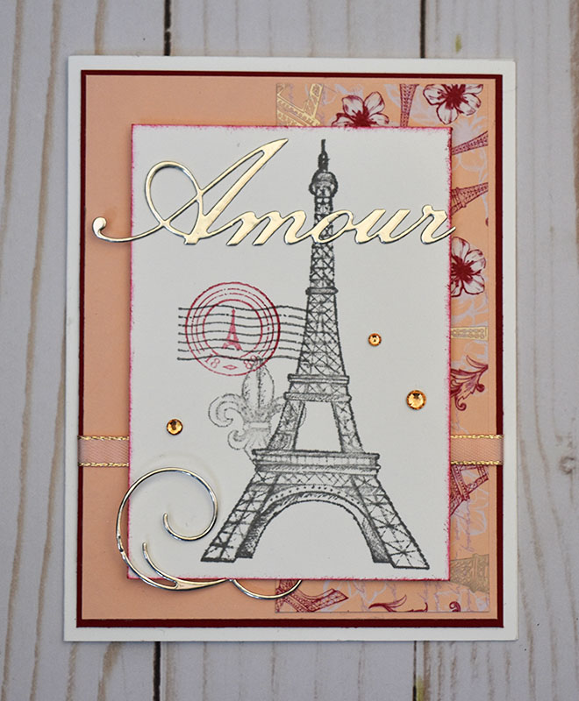

All images © 1990-2020 Stampin’ Up!®

Supplies:
Stamp Set: Parisian Beauty (151466)**
Ink: Basic Gray (149165), Cherry Cobbler (147083)
Cardstock: Whisper White Thick (140272), Whisper White (100730), Cherry Cobbler (119685), Petal Pink (146985)
Misc: Die Cut Machine, Parisian Dies (151463)**, Parisian Blossoms Specialty Designer Series Paper (151192), Fine-Tip Glue Pen (138309), SNAIL Adhesive (104332), Stampin’ Sponges (141337), Petal Pink ¼” Metallic-Edge Ribbon (151194), Champagne Foil Sheets (144748), Champagne Rhinestone Basic Jewels (151193), Stampin’ Dimensionals (104430)

Note:** Parisian Beauty Stamp Set and Parisian Dies are also available in a bundle (153778) at a 10% discount

Measurements:
- Whisper White Thick Cardstock: 8 ½” x 5 ½” – card base, score at 4 ¼”
- Whisper White: 3” x 4 ¼”
- Cherry Cobbler: 5 ¼” x 4”
- Petal Pink: 5 ½” x 3 7/8”
- DSP: 5” x 2” strip
- Champagne Foil: 3 ¾” x 3” – for die-cutting “Amour” and swirl
- Ribbon: 6”

Instructions:
- Create card base from Whisper White Thick cardstock.
- Layer DSP strip onto right edge of Petal Pink and layer this onto Cherry Cobbler piece.
- Wrap ribbon around unit from #2 and secure onto back of cardstock with SNAIL. Layer this unit onto card base.
- Ink up Eiffel Tower using Basic Gray, stamp off onto scrap paper and then, without re-inking, stamp onto Whisper White piece. Using same method, stamp fleur de lis and postage “cancel” image near stamped tower. Stamp circle image using Cherry Cobbler onto top of “cancel” image – don’t stamp off so this one will be a little darker. Sponge around this piece using Cherry Cobbler ink.
- Cut out “Amour” and swirl image using Champagne Foil and dies and attach to stamped piece using Fine-Tip Glue Pen. Tuck small end of swirl behind stamped piece and put a small amount of SNAIL on top to secure.
- Attach stamped unit to front of card using Stampin’ Dimensionals.
- Adhere several rhinestones to card front.

